**Hello Team!** **Consider the below two tables**:

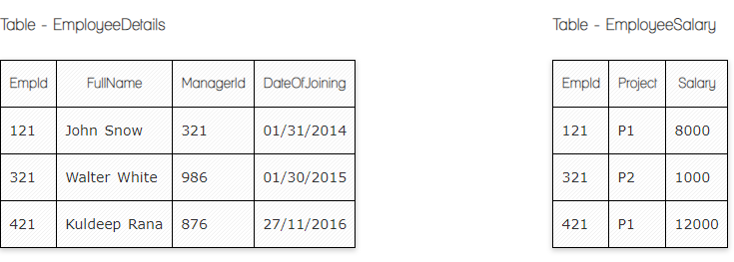

**Ques.1. Write a SQL query to fetch the count of employees working in project 'P1'.**

**Answer:**

**SELECT COUNT(*) FROM EmployeeSalary WHERE Project = 'P1';**

**Ques.2. Write a SQL query to fetch employee names having salary greater than or equal to 5000 and less than or equal 10000.**

**Answer:**

**select EmployeeDetails.Fullname from EmployeeDetails**

**inner join EmployeeSalary**

**on EmployeeDetails.EmplID=EmployeeSalary.EmplID**

**where EmployeeSalary.Salary>=5000 and EmployeeSalary.Salary<=10000**

**Ques.3. Write a SQL query to fetch count of employees sorted by project's count in descending order.**

**Answer:**

**SELECT Project, count(EmpId) EmpProjectCount**

**FROM EmployeeSalary**

**GROUP BY Project**

**ORDER BY EmpProjectCount DESC;**

**Ques.4. Write a query to fetch employee names and salary records. Return employee details even if the salary record is not present for the employee.**

**Answer:**

**SELECT E.FullName, S.Salary**

**FROM EmployeeDetails E LEFT JOIN EmployeeSalary S**

**ON E.EmpId = S.EmpId;**

**Ques.5. Write a SQL query to create an empty table with ‘Test’ name.**

**Answer:**

**create table Test (**

**ID int not null )**

**Ques.6. Write a SQL query to delete an empty table with ‘Test’ name.**

**Answer:**

**Drop table Test**

**Ques.7. Write a SQL query to fetch all the Employees details from EmployeeDetails table who joined in Year 2016.**

**Answer:**

**select \***

**From EmployeeDetails**

**where extract(year) DateOfJoining ='2016'**

**Ques.8. Write a SQL query to insert new record to the EmployeeDetails table with any data.**

**Answer:**

**insert into EmployeeDetails(DateOfJoining)**

**values('2022-08-25')**

**Ques.9. Write a SQL query to update EmployeeSalery table with setting Salary to 2000 for Project P2.**

**Answer:**

**update EmployeeSalary**

**Set Salary='2000'**

**Where Project=’P2’**

**Ques.10. Write a SQL query to right join both tables and draw the results.**

**Answer:** 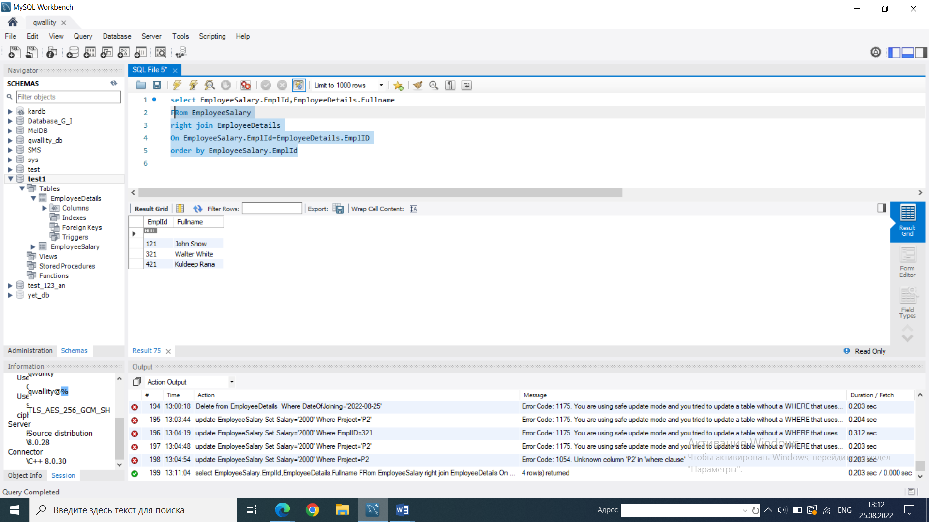

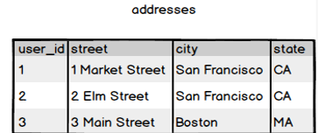

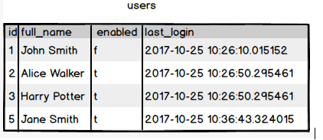

**Ques.11. Write a SQL query to fetch all users full_name from San Francisco.**

**Answer:**

**select Users.Fullname,addresses.city**

**From addresses**

**inner join users**

**on users.id=addresses.user_id**

**where addresses.city=’San Francisco’**

**Ques.12. Write a SQL query to fetch all users full_name, last_login who are enabled**

**Answer:**

**Select full_name, last_login**

**From users**

**Where enabled=’t’**

**Ques.13. Write a SQL query to fetch all users full_name who are not from Main street**

**Answer:**

**select Users.Fullname,addresses.street**

**From addresses**

**inner join users**

**on users.id=addresses.user_id**

**where Not street=’Main street’**

**Ques.14. Write a SQL query to fetch all users full_name who are from Main street or San Francisco**

**Answer:**

**select Users.Fullname,addresses.street, addresses.city**

**From addresses**

**inner join users**

**on users.id=addresses.user_id**

**where street=’Main street’ or city=’San Francisco’**

**Ques.15. Write a SQL query to fetch user full_name who is equal to user_id from Boston (find user_id value in sub_query)**

**Answer:**

**Select full_name**

**From users**

**Where users.id= 3 Harry Potter**

**(Select user_id**

**From addresses**

**Where city=’Boston’)**